CougarTutor+ Test Cases

Testing idea: These test cases check whether the Tutoring Topic / Reason field handles its character limit correctly (Maximum 300 characters). A test case compares the expected system behavior with what actually happens during testing.

Test Case 1 – Boundary value | Input: Exactly 300 characters | Expected: Counter reaches 300/300 and the application handles the maximum allowed input without a JavaScript error.  Result: Pass | Evidence:  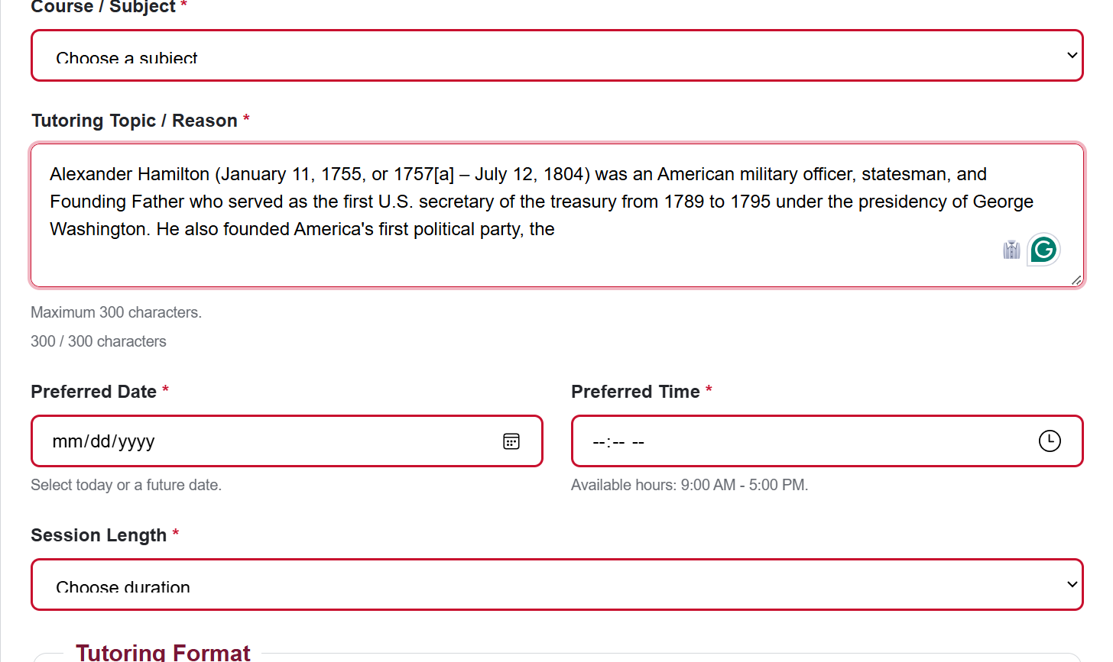  It will not let a user continue past the 300 characters.
Test Case 2 – Invalid Date | Input: Choosing a tutoring date in the past | Expected: The form rejects the selection (blocks off unavailable dates) and asks for a future date.  Result: Pass | Evidence:  Available:    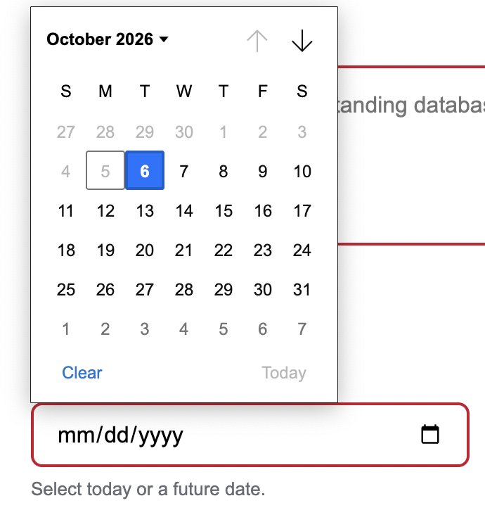  Not available:
Test Case 3 – Appointment Times | Input: Selecting a time outside & inside of available hours | Expected: The form should recognize that 5:00 PM is part of the available time since the requirement is between 9:00 AM and 5:00 PM.  Result: Fail | Evidence:  Available:  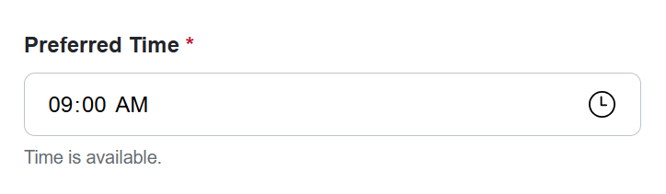  Not Available:  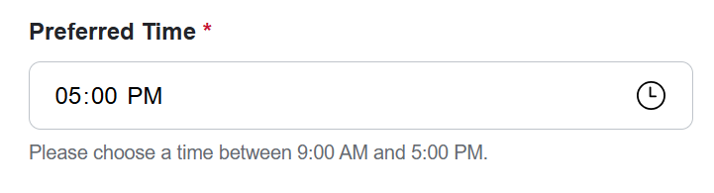

Why these tests are useful: These tests check that CougarTutor+ properly handles input limits and scheduling restrictions. The character-limit test prevents overly long session notes, while the invalid appointment date and time test prevents users from selecting an invalid tutoring time. Together, they help make the system more reliable and easier to use.

